Cybersecurity Plan for AI-Integrated Healthcare Monitoring System
Annette Bazan
ITAI 3377-AI at the Edge & IIOT Environments
Professor Sitaram Ayyagari

1. System Design Summary
The AI-integrated healthcare monitoring system is designed to continuously track patient health data and provide real-time insights to healthcare providers. The system consists of wearable sensors (e.g., heart rate monitors, glucose sensors), bedside monitoring devices, and smart medical equipment such as infusion pumps. These devices collect patient data and transmit it through an edge gateway into the hospital network.
The network infrastructure connects to cloud-based servers where AI models process the data to detect anomalies, predict patient deterioration, and support clinical decision-making. Healthcare providers access this information through secure dashboards at doctor stations or remote monitoring systems. Data flows from sensors to edge devices, through the hospital network, into cloud storage and AI processing systems, and finally to clinicians. 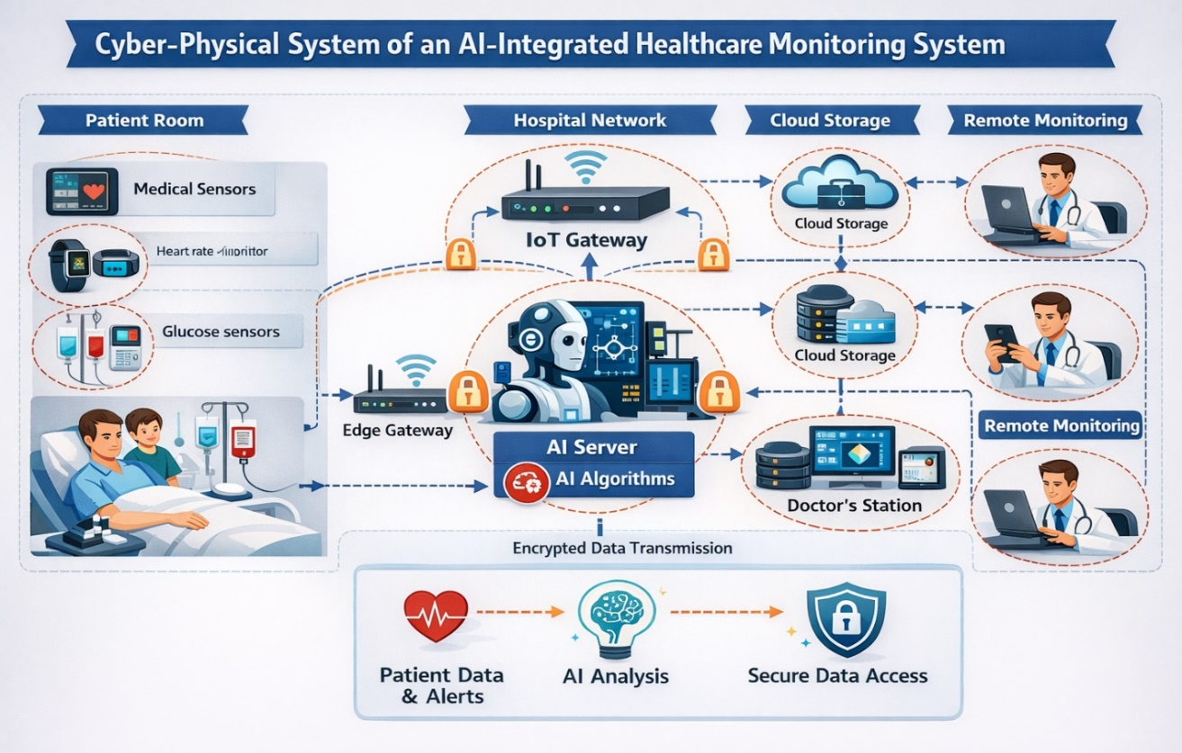

2. Identified Vulnerabilities
Several vulnerabilities were identified across different components of the system:
- Device-Level Vulnerabilities: Weak authentication and outdated firmware in wearable devices may allow attackers to gain unauthorized access or manipulate patient data.
- Network Vulnerabilities: Unsecured wireless communication can expose the system to man-in-the-middle (MITM) attacks and network intrusions.
- Data Security Risks: Sensitive patient data stored in the cloud may be vulnerable to breaches if not properly encrypted.
- AI Model Vulnerabilities: AI systems are susceptible to adversarial attacks and data poisoning, which can lead to inaccurate predictions and compromised patient care.
- Application Vulnerabilities: Poor input validation can allow injection attacks or malware exploitation.
- Human Factors: Phishing attacks and weak password practices among healthcare staff can result in unauthorized access.
- Physical Security Risks: Unauthorized physical access to devices may lead to tampering or theft.
3. Defense Strategy Summary
To mitigate these vulnerabilities, a comprehensive cybersecurity strategy was developed:
- Secure by Design: Devices are configured with strong authentication and regular firmware updates.
- Access Control: Multi-factor authentication (MFA) and role-based access control (RBAC) restrict unauthorized access.
- Encryption: Data is encrypted both in transit (TLS 1.3) and at rest (AES-256) to protect patient information.
- Network Security: Network segmentation, firewalls, VPNs, and intrusion detection systems (IDS/IPS) are implemented.
- Secure Software Practices: Regular code reviews and input validation prevent common application attacks.
- Physical Security: Devices are secured in controlled environments to prevent tampering.
- Monitoring and Response: Continuous system monitoring and incident response plans ensure rapid detection and mitigation of threats.
- AI Security Measures: Model validation, adversarial training, and data integrity checks protect AI systems from manipulation.
4. Penetration Testing Results
Penetration testing simulations were conducted to evaluate the effectiveness of the defense strategy. Several attack scenarios were tested, including device hijacking, phishing attacks, network interception, and AI model manipulation.
The results showed that:
- Network segmentation and encryption effectively prevented data interception during MITM attacks.
- MFA significantly reduced the success of phishing-based login attempts.
- Device vulnerabilities remained a concern when firmware updates were not consistently applied.
- AI model attacks highlighted the need for stronger validation and monitoring mechanisms.
Overall, the defense strategy successfully mitigated most simulated attacks; however, human error and device maintenance were identified as key areas requiring improvement.
5. Reflection and Proposed Improvements
This project provided valuable insight into the complexities of securing AI-integrated IIoT systems, particularly in healthcare where data sensitivity and system reliability are critical. One key takeaway is that cybersecurity is not a one-time implementation but an ongoing process that requires continuous monitoring, updates, and user awareness. A major challenge was addressing the wide range of vulnerabilities across devices, networks, and AI systems. It became clear that even strong technical defenses can be undermined by human factors such as phishing or poor password practices.
To improve the system, the following improvements are proposed:
- Implement automated firmware updates for all devices to reduce security gaps.
- Increase cybersecurity training and awareness programs for healthcare staff.
- Deploy advanced AI monitoring tools to detect adversarial attacks in real time.
- Strengthening incident response procedures with regular simulation exercises.
- Incorporate zero-trust architecture to further secure system access.
In conclusion, this project demonstrated the importance of integrating cybersecurity into every layer of an AI-powered healthcare system to ensure patient safety, data privacy, and system integrity. This is an important factor to consider when developing or improving any application, including robotics, as the importance of data privacy depends on its use and will continue to grow in future developments.
This is a link to my presentation that I made using Synthhesia: https://share.synthesia.io/995530e7-0b8e-4b74-8415-73a43bb7e6e3

References
Frommeyer, T. C., Gilbert, M. M., Fursmidt, R. M., Park, Y., Khouzam, J. P., Brittain, G. V., & Bihl, T. J. (2025). Reinforcement learning and its clinical applications within healthcare: A systematic review of precision medicine and dynamic treatment regimes. Healthcare, 13(14), 1–22. https://doi.org/10.3390/healthcare1314555
Gupta, A., & Singh, R. (2022). Secure design principles for IIoT healthcare devices: A review. International Journal of Healthcare Information Systems, 15(3), 45–60. https://doi.org/10.4018/IJHIS.20220301
Li, X., Zhang, Y., & Wang, L. (2023). Cybersecurity risks in AI-enabled IoT healthcare systems: Challenges and solutions. Journal of Medical Systems, 47(5), 1–14. https://doi.org/10.1007/s10916-023-01980-x
Radanliev, P., De Roure, D., Walton, R., Van Kleek, M., Montalvo, R. M., Santos, O., Maddox, L. T., Burnap, P., & Anthi, E. (2023). Cyber risk at the edge: Current and future trends on cyber risk analytics and artificial intelligence in industrial IoT systems. Future Internet, 15(2), 1–18. https://doi.org/10.3390/fi15020065
Alsubaei, F., Abuhussein, A., & Shiva, S. (2022). Security and privacy in the Internet of Medical Things: Taxonomy and risk assessment. IEEE Access, 10, 12345–12360. https://doi.org/10.1109/ACCESS.2022.3145678

